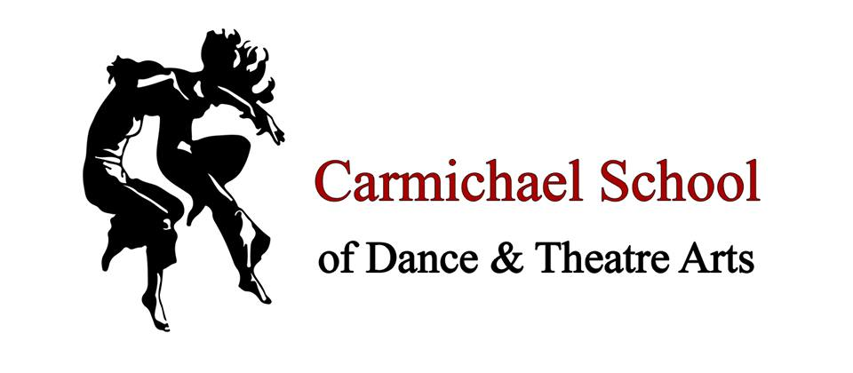
Dear Students and Parents of Carmichael School of Dance and Theatre Arts,
We here at Carmichaels want to still provide the children with as much education and entertainment as we can from the confinements of our homes. With the recent announcement from the government about wages for the self-employed, we are in discussions with the team as to the best course of action should this lockdown continue for the next few months – going into the summer term. The students are our priority and maintaining their mental and physical health is always paramount to us in these uncertain times.
Our initial plan currently is to provide two levels of dance classes online via ZOOM or Youtube.
The first level is to provide some free classes, if you can’t afford to pay for classes in the current state of financial uncertainty, your child can still partake in Carmichaels classes see their friends online and keep up with their dancing. Ideas like : Easter Workshop with Miss Nicola” where Miss Nicola could teach the students crafts and baking through video as if they were still attending our workshop which was planned in the holidays.
The second level is our paid dance, drama and singing graded classes. We will create a timetable and pricing list for you all to view. (fees to be determined but will be priced lower than our usual rates) providing our usual high quality of teaching and the students will still be progressing with their graded studies.
This is still all very flexible as nothing is set in stone yet; we are just reaching out to you all to start a conversation. We therefore want to know what your thoughts and intentions are regarding your child’s dance classes with us in the coming months of summer term. Please message us via email, Facebook messenger, Instagram, carrier pigeon etc. We can then plan and set up in accordance with your needs and wishes.
We look forward to hearing back from you,

Miss Nicola, Mr Mark, Miss Liv and the rest of the Carmichaels Team.
